

NATIONAL INSTITUTE OF TECHNOLOGY KARNATAKA

SURATHKAL, MANGALORE - 575 025

Course Code – CS111

Course Name – Computer Programming Lab

Lab - 02

Date – May 5, 2021

Submitted To

Marwa Mohiddin Ma’am

Department of Computer Science and Engineering

National Institute of Technology Karnataka, Surathkal

Submitted By

Md Rakib Hasan

Roll – 201CS132

Department of Computer Science and Engineering

**Question - 1**

To find Simple and Compound Interest

**Answer**

#include<stdio.h>

#include<math.h>

int main()

{

    float total_amount, rate, time, s_i, c_i;

    printf("Enter total amount: ");

    scanf("%f",&total_amount);

    printf("Enter rate(%%): ");

    scanf("%f",&rate);

    rate = rate/100;

    printf("Enter time(year): ");

    scanf("%f",&time);

    //calculating simple and compound interests

    s_i = total_amount*rate*time;

    c_i = (total_amount*(pow((1+rate),time)))-total_amount;

    printf("\nSimple Interest = %.2f\n",s_i);

    printf("Compound Interest = %.2f\n",c_i);

    return 0;

}

**Output**

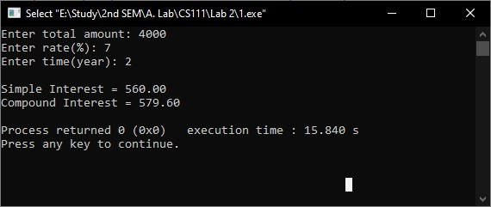

**Question – 2**

To read the radius of a circle and find its Area and Perimeter.

**Answer**

#include<stdio.h>

#define PI 3.1416

int main()

{

    int radius;

    float area, perimeter;

    printf("Enter the radius of a circle: ");

    scanf("%d", &radius);

    //calculating area and perimeter

    area = PI*radius*radius;

    perimeter = (2*PI*radius);

    printf("\nArea = %.2f\n", area);

    printf("Perimeter = %.2f\n", perimeter);

    return 0;

}

**Output**

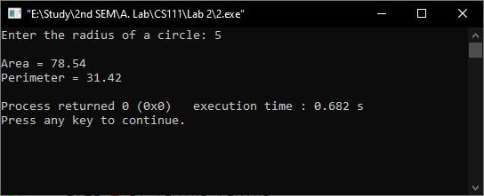

**Question – 3**

To read the temperature in Fahrenheit and convert it to degree centigrade.

**Answer**

#include<stdio.h>

int main()

{

    float F, C;

    printf("Enter temperature in Fahrenheit: ");

    scanf("%f", &F);

    //convert temperature into degree centigrade

    C = (F-32)*5/9;

    printf("\nTemperature in degree centigrade: %.2f\n", C);

    return 0;

}

**Output**

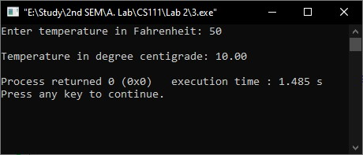

**Question – 4**

Program to accept student roll no, marks in 3 subjects and calculate total, average of marks and print them with appropriate messages.

**Answer**

#include<stdio.h>

int main()

{

    int roll;

    float mark[3], sum=0, avg;

    printf("Enter roll: ");

    scanf("%d",&roll);

    int i;

    //taking marks and calculate total

    for(i=0; i<3; i++)

    {

        printf("Enter marks for subject %d: ", i+1);

        scanf("%f", (mark+i));

        sum += mark[i];

    }

    avg = sum/3;

    printf("\nRoll %d:\n",roll);

    printf("Total marks = %.2f\n", sum);

    printf("Average = %.2f\n",avg);

    return 0;

}

**Output**

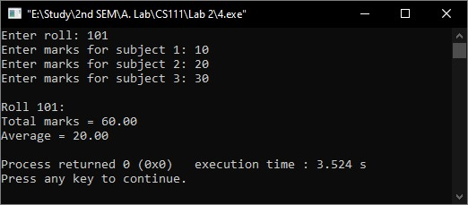

**Question – 5**

An Employee's Basic Pay (BP) is to be read through keyboard. DA is 40% of BP, HRA is 20% of BP, calculate the Gross Pay (GP) GP is computed as BP+DA+HRA.

**Answer**

#include<stdio.h>

int main()

{

    float BP, DA, HRA, GP;

    printf("Enter Basic Pay: ");

    scanf("%f",&BP);

    //Calculation

    DA = BP*40/100;

    HRA = BP*20/100;

    GP = BP+DA+HRA;

    printf("\nGross Pay: %.2f\n",GP);

    return 0;

}

**Output**

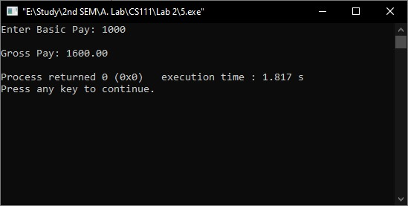

**Question – 6**

Program to find distance between two points (x1, y1) and (x2, y2) in a Cartesian plane.

**Answer**

#include<stdio.h>

#include<math.h>

int main()

{

    int x1, y1, x2, y2;

    printf("Enter the value of x1,y1: ");

    scanf("%d %d",&x1,&y1);

    printf("Enter the value of x2,y2: ");

    scanf("%d %d",&x2,&y2);

    // calculate distance

    float dis;

    dis = sqrt(pow((x2-x1),2)+pow((y2-y1),2));

    printf("\nDistance = %.2f\n",dis);

    return 0;

}

**Output**

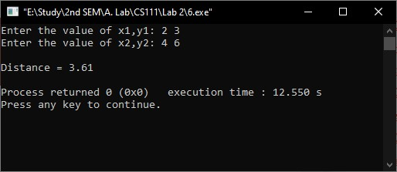

**Question – 7**

Program to swap two numbers using temporary variable. Also print the original and exchanged values

**Answer**

#include<stdio.h>

int main()

{

    float n1, n2;

    printf("Enter the value for Number1 & Number2: ");

    scanf("%f %f",&n1,&n2);

    printf("\nBefore swipe number1 = %f & number2 = %f\n",n1, n2);

    //swipe

    float temp = n1;

    n1 = n2;

    n2 = temp;

    printf("After swipe number1 = %f & number2 = %f\n",n1, n2);

    return 0;

}

**Output**

